# Exercises Unit 5.1 A. MANAGING DIRECTORIES

1.Change the current directory to /home/<user>:

We can just type **pwd.**

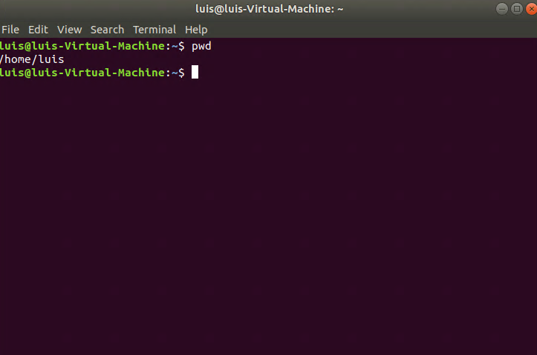

2.Create a directory called systems:

With: **mkdir (directory_name) : mkdir systems**

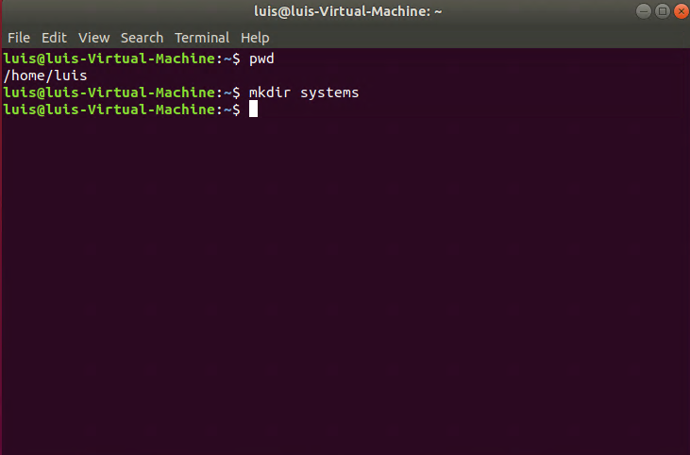

3.Create a directory called exercises. Go to this directory and create another new directory called programming.

We need to create the “exercises” directory by typing **mkdir exercises**, then **cd exercises** to acceses the directory and create inside exercises a new directory called programming with **mkdir programming.**

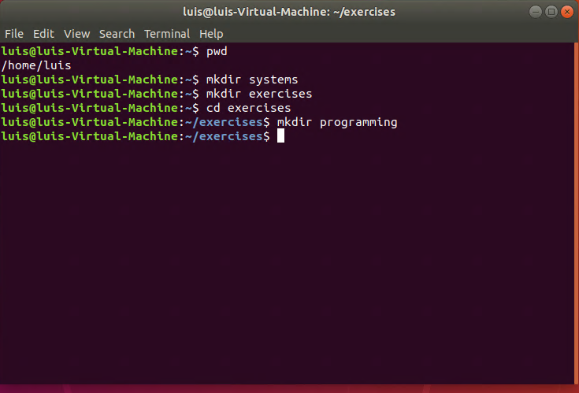

4.Go back to the user’s home directory. Delete the directories “exercises” and “programming” using just one command. Create the directories again with one command.

We will need to go to our HOME directory with **cd** comand and then type **rmdir -p exercises/programming**, which will delete both directories.

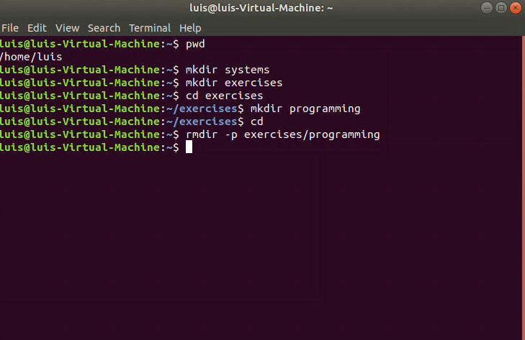

We will type **mkdir -p exercises/programming** to create both with this command.

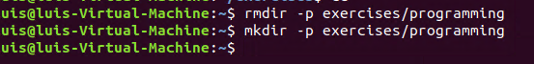

5.Print the contents of the root directory

To list all the files in the “root” directory, we will have to access it first. To do this, we will type **sudo su.** After that, located in the “root”, we will type **ls** to display the data.

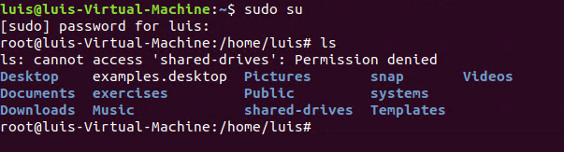

6.Print all the files and directories that begin withd in the /usr/bin directory

First we need to be located in this directory by typing **cd /usr/bin** . Then we will need to type **ls -d d*.**

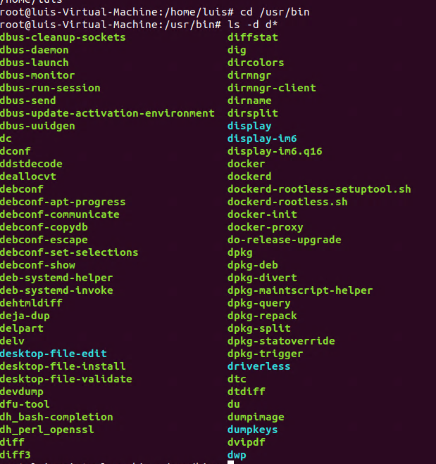

7.List all the files and directories in /etc, including subdirectories

l**s –R** and then add “/**etc**” so the command would be like this **ls -R /etc.**

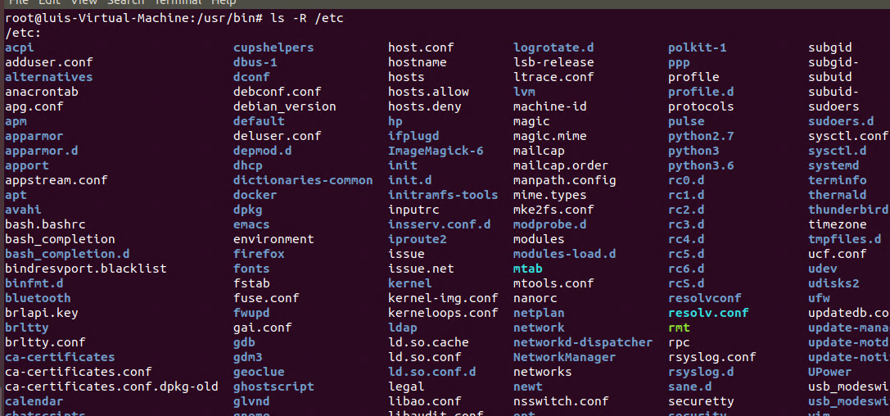

8.Create the empty files called student.txt, student1.txt, student2.txt, list, luggage and last in the directory named “systems”.

We need to type **cd systems** to locate inside it and then with **touch** to create the files. We will do it with 1 command: **touch student.txt student1.txt student2.txt list luggage last.**

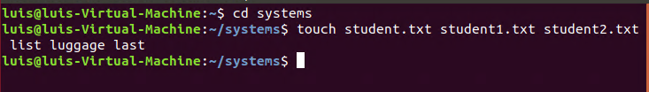

9.Print all the files that begin with “l” in the directory “systems”.

To list the files that start with “l” in “systems” we will have to type **ls -d l\***.

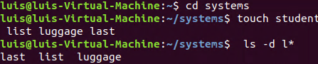

10.Print all the files that end with “txt” in the directory “systems”.

To list all the files that finish with “txt” in “systems” we will have to type **ls -d *txt**.



11.Create a new directory into $HOME called “config”.

To create a new directory in “home” we will have to go back with **cd ..** and creating the new one, called “config” **mkdir config**.

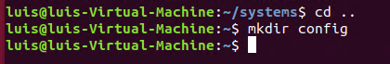

12.Copy all the files in /etc which begin with “a” into “config”.

**sudo cp -R /etc/a* /home/config** . The route will be diferente for each people.

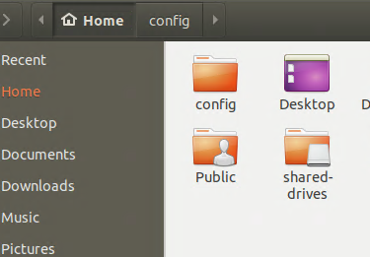

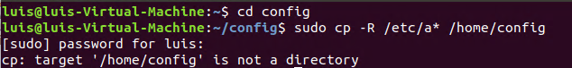

13.Delete all the files in “config” which end with “conf”.

**rm -i *conf**



14.Create the following files using nano (or another editor): song.doc(write a few lines of a song) in the directory Egypt; tv.doc(write the name of your favourite TV programs) in the directory Seuland marks (write the marks you expect to get this year) in the directory Tunisia.

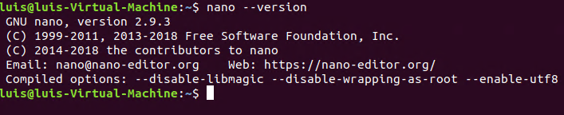

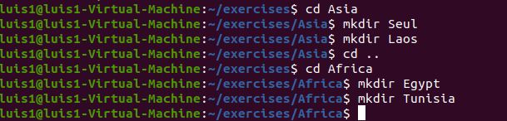





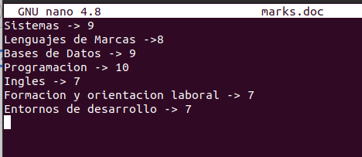

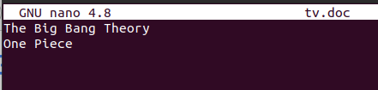

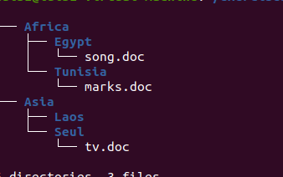

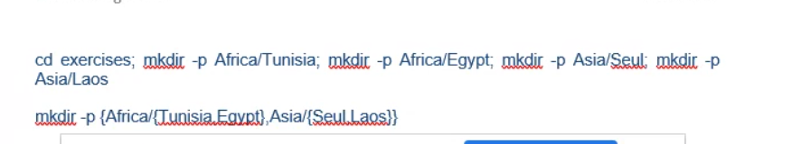

**CHANGE THE CURRENT DIRECTORY TO AFRICA AND DO THE FOLLOWING EXERCISES USING RELATIVE PATHS**

15. Copy the file “song.doc” into “Laos”



16. Copy the file “tv.doc” into “Egypt” with the name “radio.txt”



17. Rename the file “marks” to “exam.wri” (it is located in the directory named Tunisia)



18. Copy the file “song.doc” (located in “Egypt”) inside “Tunisia”



19. Print the content of the current directory using long listing format

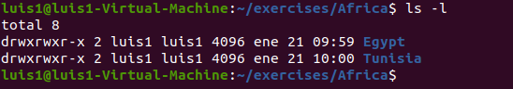

20. Rename the file “song.doc” (located in “Laos”) to “aa.doc”



21. Create the directory “Others” in “Laos”



22. Rename the directory named “programming” (which you created in the first exercises) to

pro-c.



23. Create the following directory tree in “exercises” (using as few commands as possible)

ONE

TWO THREE



24. Copy the files with txt extension from the directory named “systems” to “exercises”.



25. Move the files you copied in the exercise above to the directory THREE.



26. Delete the directory named THREE, including all the files and, if so, subdirectories.



1. Copy the files that end with “txt” of the directory named “systems” to “Tunisia”



1. Copy the file “tv.doc” (located in “Seul”) to the directory named “exercises”



1. Rename the file student1.txt (located in “Tunisia”) to tuition.txt



1. Create a new directory called “earth” into “systems”. Create another directory called “countries” inside “earth”



1. Rename “Africa” (located in “exercises”) to “Afri”



1. Move the file “song.doc”, which is located in Egypt, to “Laos” with the name “bb.doc”



1. Copy the files whose name contains the letter “u” from “systems” to “exercises”



1. Print the content of the /etc directory, including subdirectories, in reverse alphabetical order

ls –rR /etc

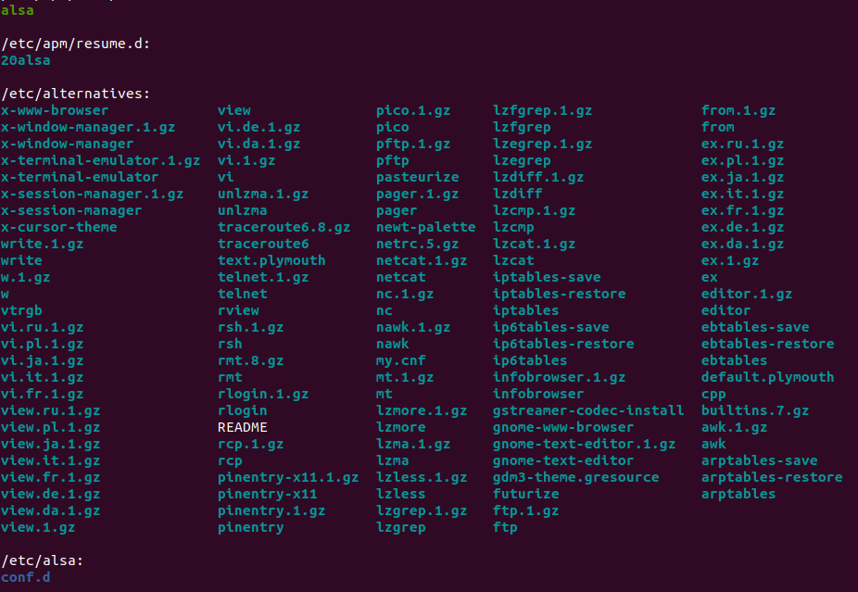

1. How can you print the name of the current directory?



1. Copy the folder “Afri” including files and subdirectories to “Asia”



1. Move all the files and subdirectories of “Laos” to “Seul” and rename it to “Seul2”

